Components of Hbase (3 main components) 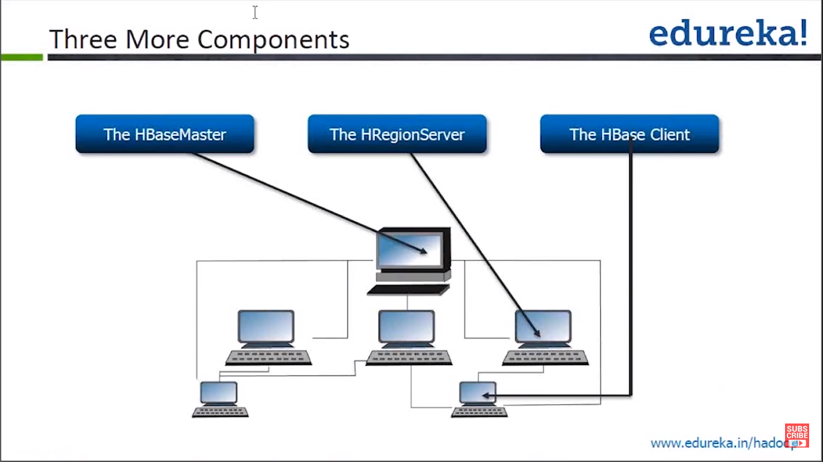
- Hmaster
- It involves the active Hmaster and Standby Hmaster
Active Hmaster: Manage Region Servers in Hbase including:
- Creating, deleting, Modifing, and Quering of tables.
- Balancing of the load of region servers, adjust the distribution of the regions, Split regions, and distribute regions after they are split.
- Migrate regions after a region Server fail.
Standby Hmaster
- Takes over the services when the active Hmaster fails.
- Region Server:
- Manages the regions (each region is sub-table).
- Provides read and write services of table data as a data processing and computing unit in Hbase.
- Region server is usually deployed with the data node of HDFS cluster to perform data storage.
3- Client: Communicate with Hmaster and Region Server by Hbase PRC mechanism.
- Client communicates with Hmaster for management.
- Client communicates with Region server for Data operation (Read/Write).
ZooKeeper: Provides distributed coordination services for processes in the Hbase cluster.
- Each Region Server is registered with the zoo keeper, so the active Hmaster can obtain the health status of each region server.
Hdfs: provides high reliable file storage service for Hbase. (Almost Hbase data is stored in HDFS).
it means that Apache ZooKeeper helps manage and coordinate the different components (or nodes) in an HBase cluster to work together reliably and efficiently.
Let’s break it down simply:

🔧 What is ZooKeeper?
ZooKeeper is a centralized coordination service used in distributed systems like HBase. It handles tasks such as:
- Leader election
- Maintaining configuration information
- Providing synchronization
- Managing distributed locks

🧠 In HBase, what needs coordination?
HBase has multiple moving parts:
- HMaster: manages the cluster (like a manager).
- RegionServers: store the actual data (like workers).
- Clients: applications that read/write data.
They all need to:
- Know who is the current HMaster
- Know which RegionServer handles which data
- React properly if a RegionServer fails
- Avoid conflicting operations

🤝 What ZooKeeper Does for HBase:
- Keeps Track of Master Server:
If the HMaster fails, ZooKeeper helps elect a new one.
- Manages RegionServers:
ZooKeeper knows which RegionServers are alive and helps assign regions (chunks of the table) to them.
- Client Discovery:
Clients ask ZooKeeper to find which server has the data they want.
- Failure Detection:
ZooKeeper quickly detects when a RegionServer crashes and notifies the HMaster to recover and redistribute the data.

🔄 Without ZooKeeper?
- HBase wouldn’t know how to handle failures or assign tasks.
- You'd risk data loss, downtime, and conflicts.

📌 In Summary:
ZooKeeper is like the air traffic control for the HBase cluster. It doesn't store data, but it makes sure all the components are talking to each other and behaving correctly, especially when things go wrong.
What is inside the Region Server? (5 Components of a region) (Store, Memstore, StoreFile, HFile, HLog)
- Store.
- Any region consists of one or multiple stores. Each store corresponds to a column family.
- MemStore.
- A store contains one MemStore. Data inserted to a region by a client and cached to a MemStore.
- When the Memstore capacity reaches the upper limit, regionServer flush data from the Memstore to the HDFS.
- Store File
- As more Data is inserted, Multiple store files are generated in the store.
- When the numbers of store files reach the upper limit, Region server merges multiple Store files into a big Store File.
- The data flushed to Hdfs is stored as a store file in HDFS.
- HFile
- Defines the storage format of the storage files in the file system.
- HLog:
- Prevent data lost when a region server fails. Multiple Regions in the region Server can share the same HLog.
Region

HLog

Store (ColumnF)

Store (ColumnF)

MemStore

StoreFile

StoreFile

MemStore

StoreFile

StoreFile

StoreFile

StoreFile

Flush
HDFS

DataNode

DataNode

DataNode

DataNode

Similar to name node and data node
Name node: Monitoring the whole storage process.
Data node: where the actual execution is happened.
Similar to this Architecture
Hmaster: control the hbase cluster.
HbaseRegionServer: store the actual data and retrieve them
HbaseClient: interact with hbase

